# NNF and PNF 1M8

Based on the parameters for SNF 1M8 model, which is listed below

|  |  |
| --- | --- |
| Choice of parameters for SNF 1M8 homozygous diploid | |
| Parameter | Value |
| Kd | 0.3 |
| At0 | 6 |
| alpha | 7 |
| Vmax (MM degradation Vmax) | 1.3 |
| Km | 1 |
| Ka | 1 |

At = At0*FCATR = 6 is the total amount of BMAl

Dimensional $\hat{At }$ = At *C, where C = $\hat{Kd}/Kd$ =2/0.3 = 6.7,

therefore, $\hat{At }=$ 0.9 nM

When introduced the addition negative feedback loop in NNF model, average BMAL (At) wants to be similar to the BMAL level.

**Modified Kim-Forger NNF model.** Equations (10)-(14) plus

|  |  |  |
| --- | --- | --- |
|  | $$\frac{dA_{\text{T}}}{dt}=δ\left[A_{MAX}\frac{K_{\text{V}}}{V+K_{\text{V}}}-A_{\text{T}}\right]$$ | (16) |
|  | $$\frac{dV}{dt}=δ\left[V_{MAX}F(A_{\text{free}})-V\right]$$ | (17) |

$$δ=0.2, V_{MAX}=1$$

**Modified Kim-Forger PNF model.** Equations (10)-(14) plus

|  |  |  |
| --- | --- | --- |
|  | $$\frac{dA_{T}}{dt}=δ\left[A_{MAX}\frac{R}{R+K_{\text{R}}}-A_{\text{T}}\right]$$ | (18) |
|  | $$\frac{dR}{dt}=δ\left[R_{MAX}F(A_{\text{free}})-R\right]$$ | (19) |

NNF 1M8

|  |  |
| --- | --- |
| Vmax (max Rev) | 1 |
| Km | 1 |
| Ka | 1 |
| delta | 0.2 |

Kv=0.1, Amax=16 s.t average BMAL At=6, max(V) = 0.2 (50,000 Rev molecules from experiment)

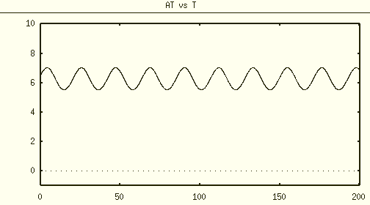

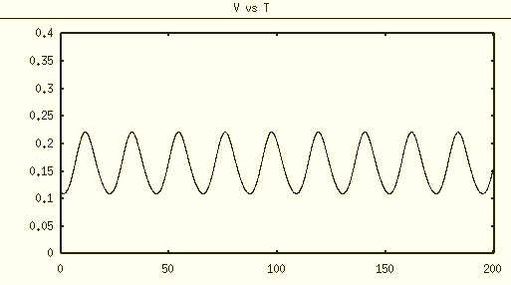

For PNF 1M8 model

Same parameter value as NNF1M8 and SNF 1M8

|  |  |
| --- | --- |
| Rmax (max Ror) | 1 |
| Km | 1 |
| Ka | 1 |
| delta | 0.2 |
| Kd | 0.3 |
| At0 | 6 |
| alpha | 7 |
| Vmax (MM degradation Vmax) | 1.3 |
| Km | 1 |
| Ka | 1 |
| Kr | 0.1 |

Tune Amax = 12 s.t. average At = 6

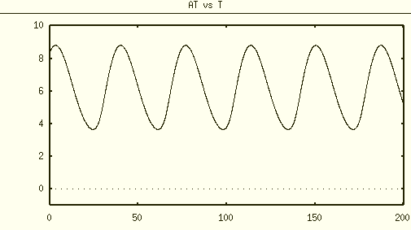

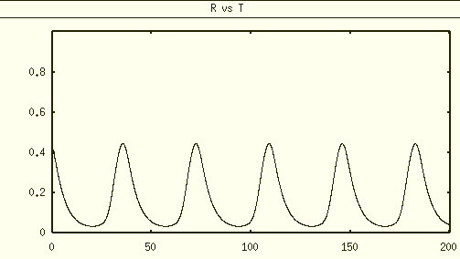

7/3/2021

NNF

delta, Amax, Kv